Analyze and visualize the distribution of various data science roles from a dataset

roles= ['Data Analyst', 'Data Engineer', 'Data Scientist', 'ML Engineer",

'Business Analyst'] counts =[300, 500, 450, 200, 150] plt.bar(roles, counts) plt.title('Distribution of Data Science Roles’) plt.xlabel('Role') plt.ylabel('Count') plt.show()

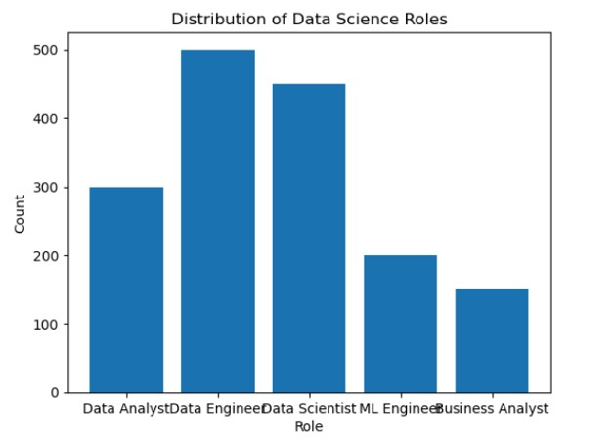

CONDUCT AN EXPERIMENT TO ENCRYPT AND DECRYPT GIVEN SENSITIVE DATA.

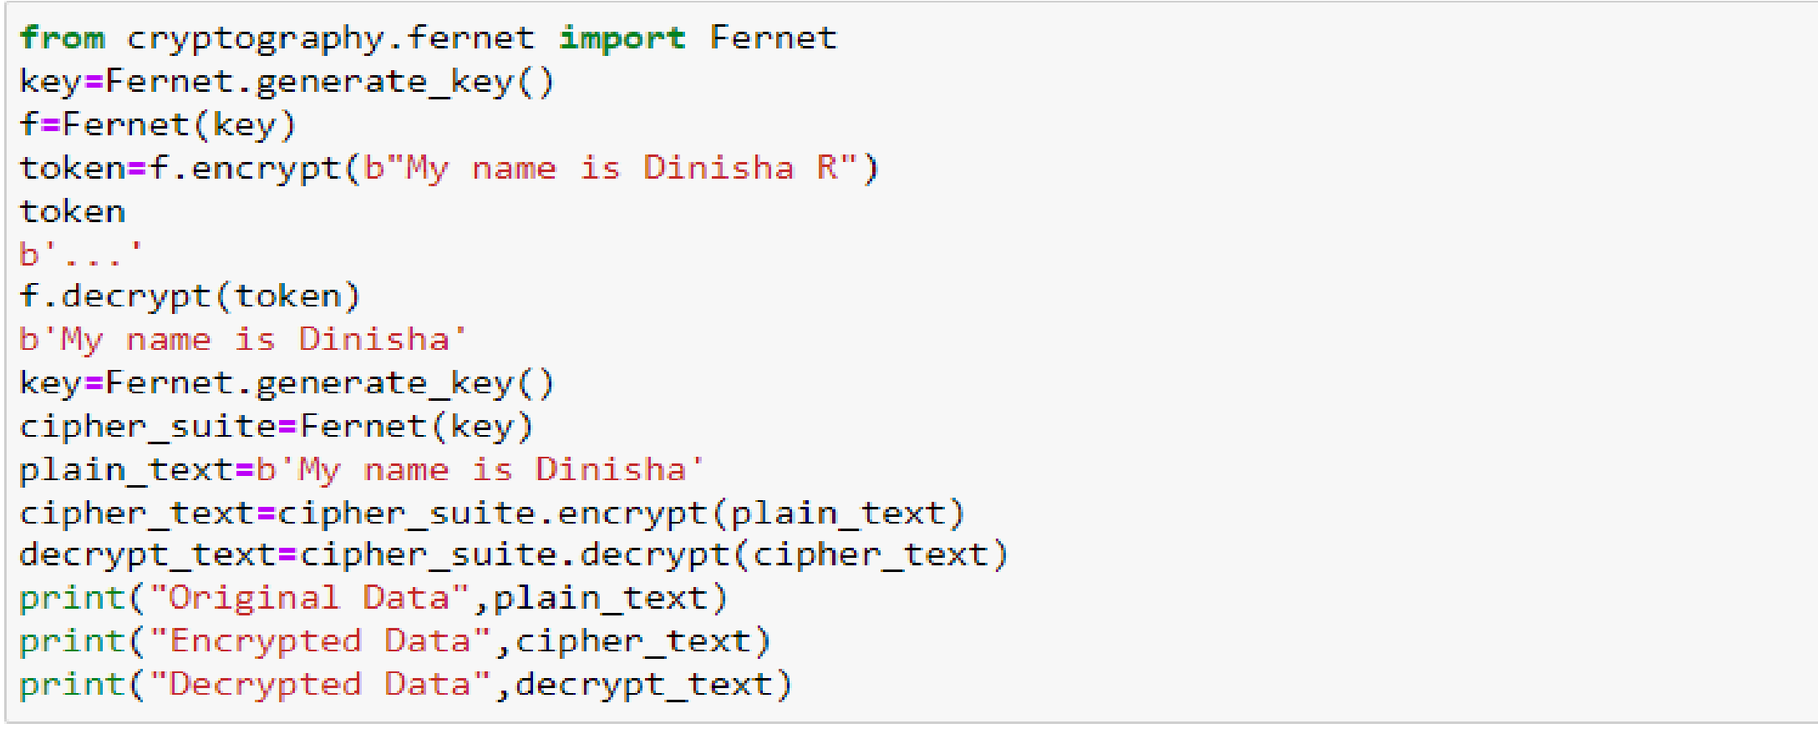



*Count the frequency of occurrence of a word in a body of text is often needed during text processing.*

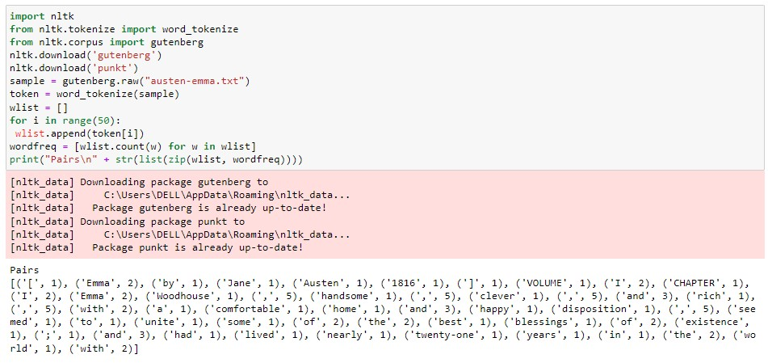

*Data Cleaning*

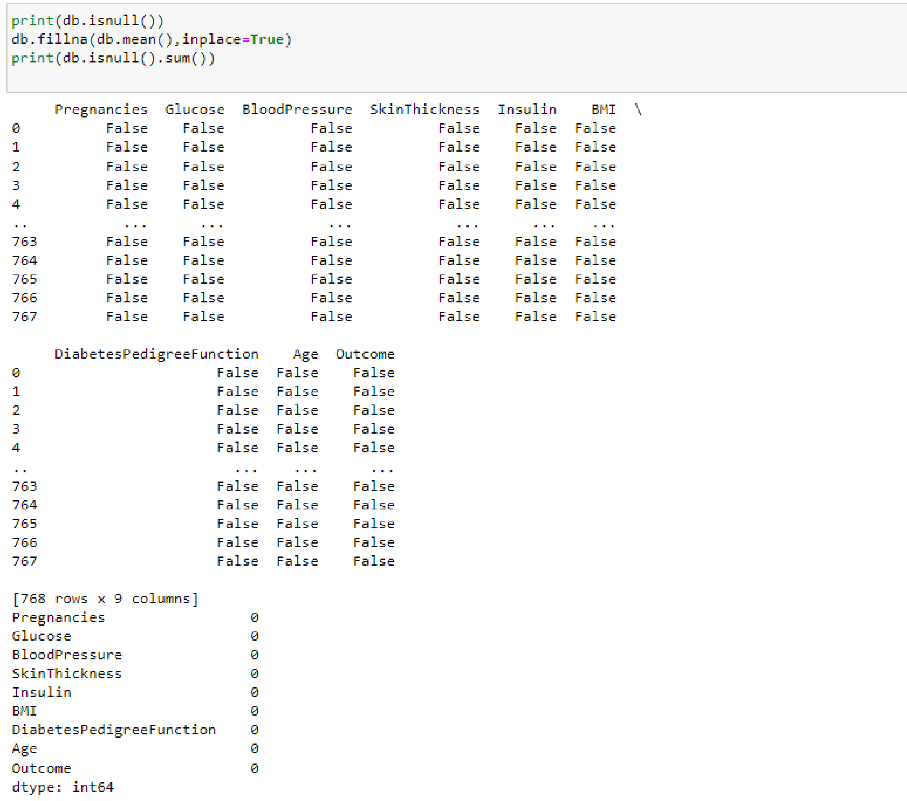

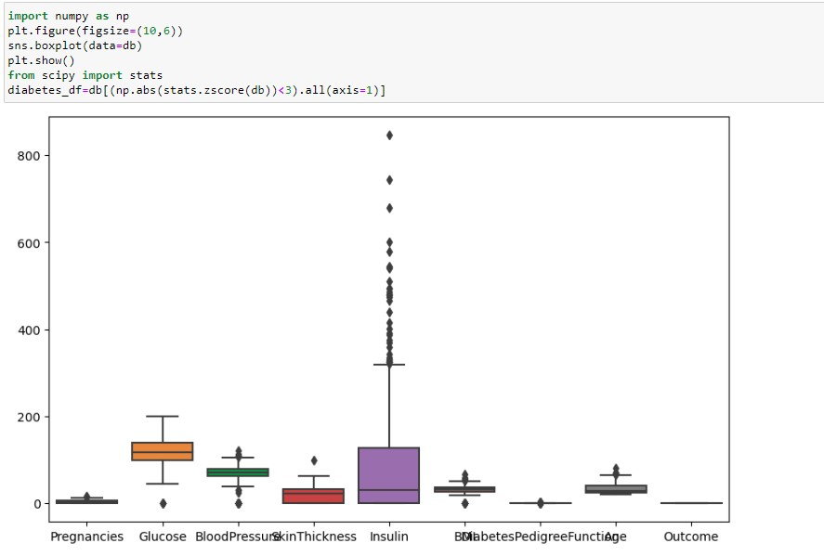

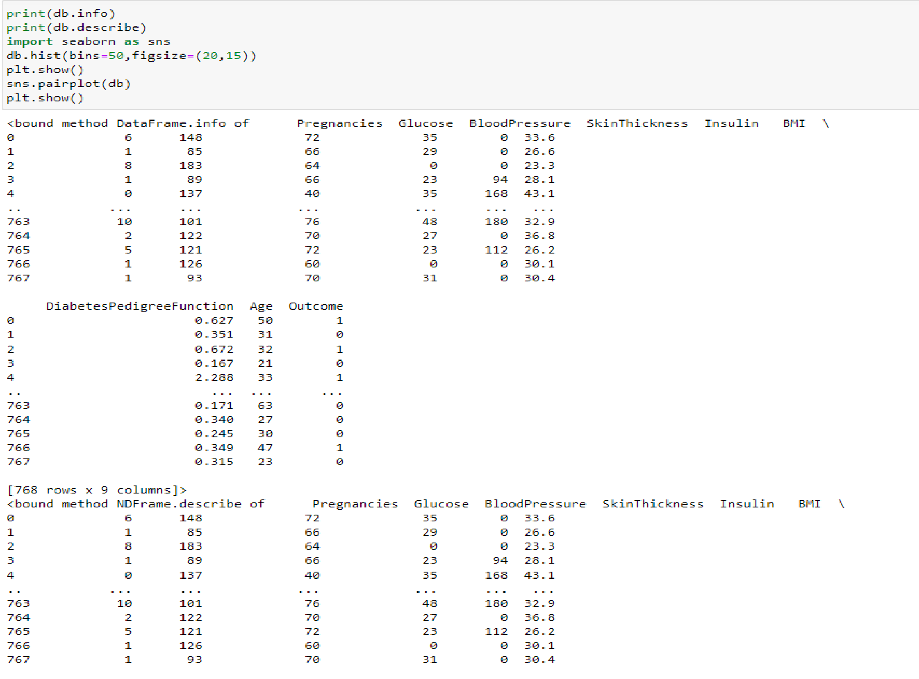*Data Collection and Initial Exploration*

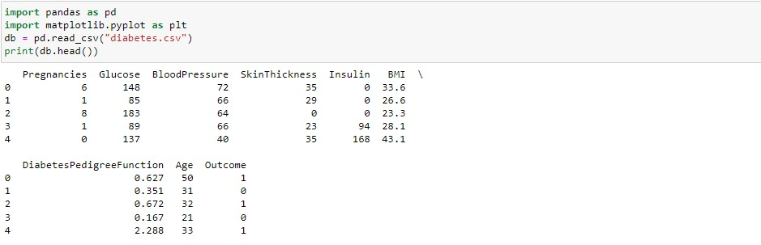

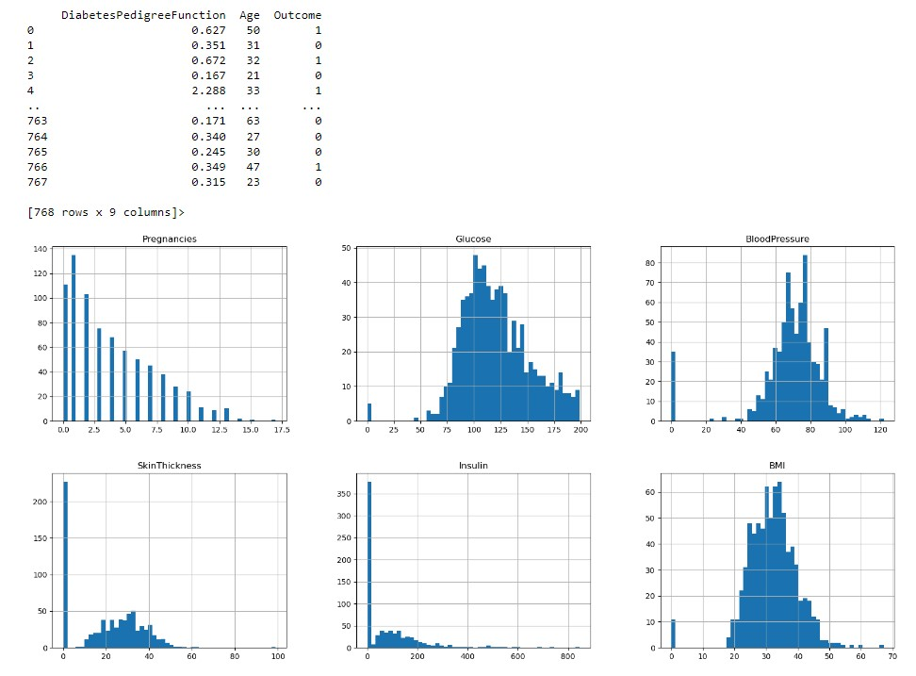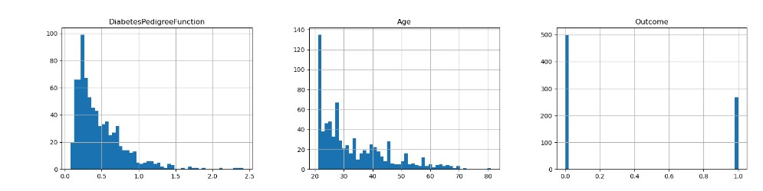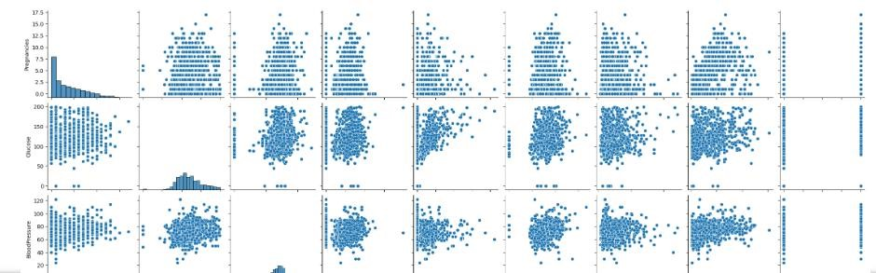

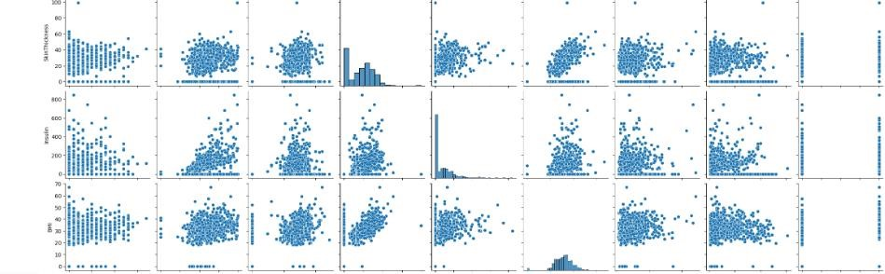

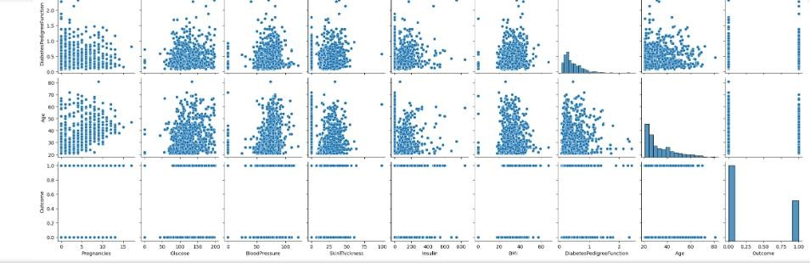

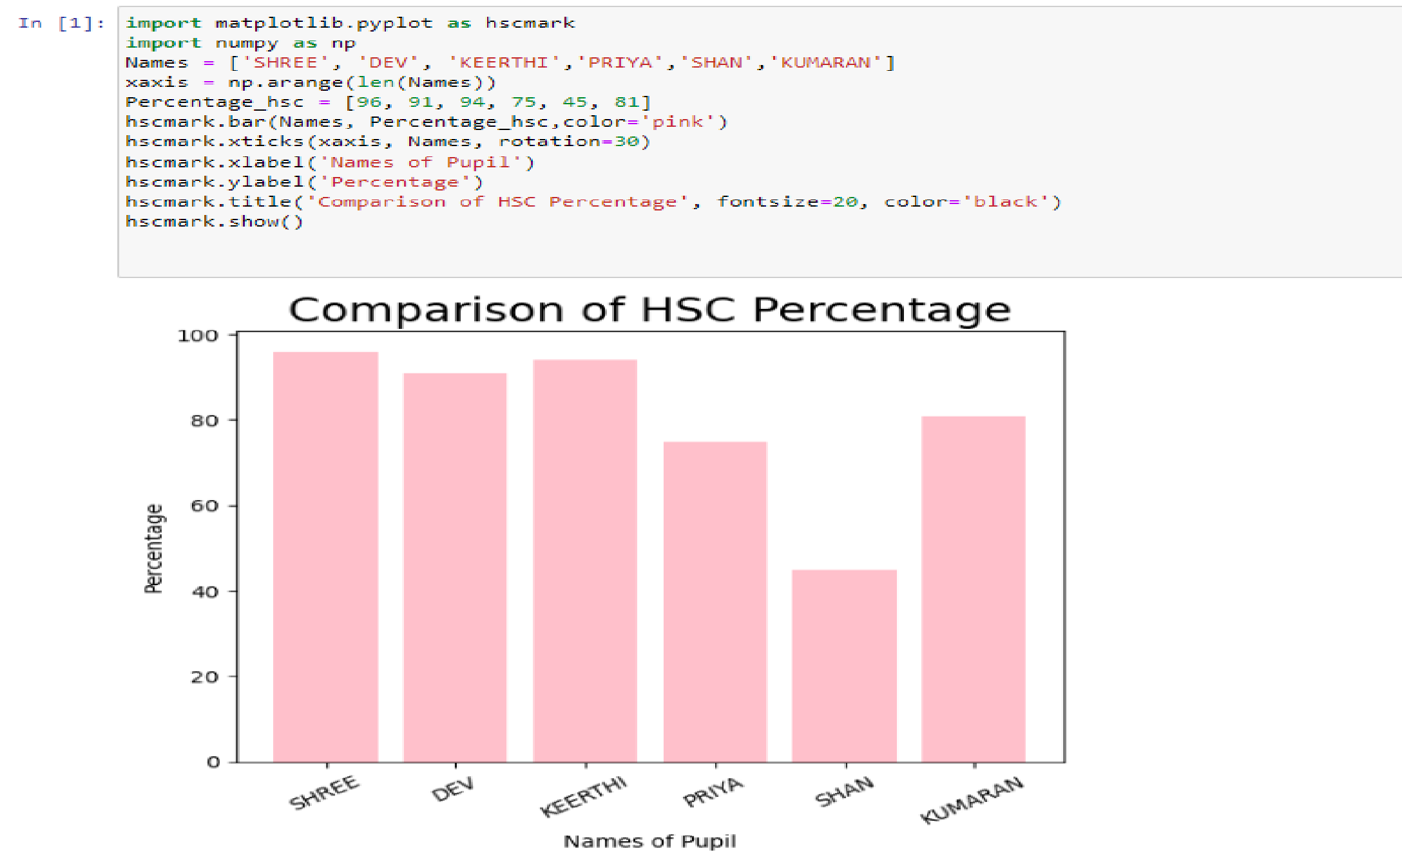*Experiment to show data visualization using bar chart*

*Experiment to show data visualization using line plot*

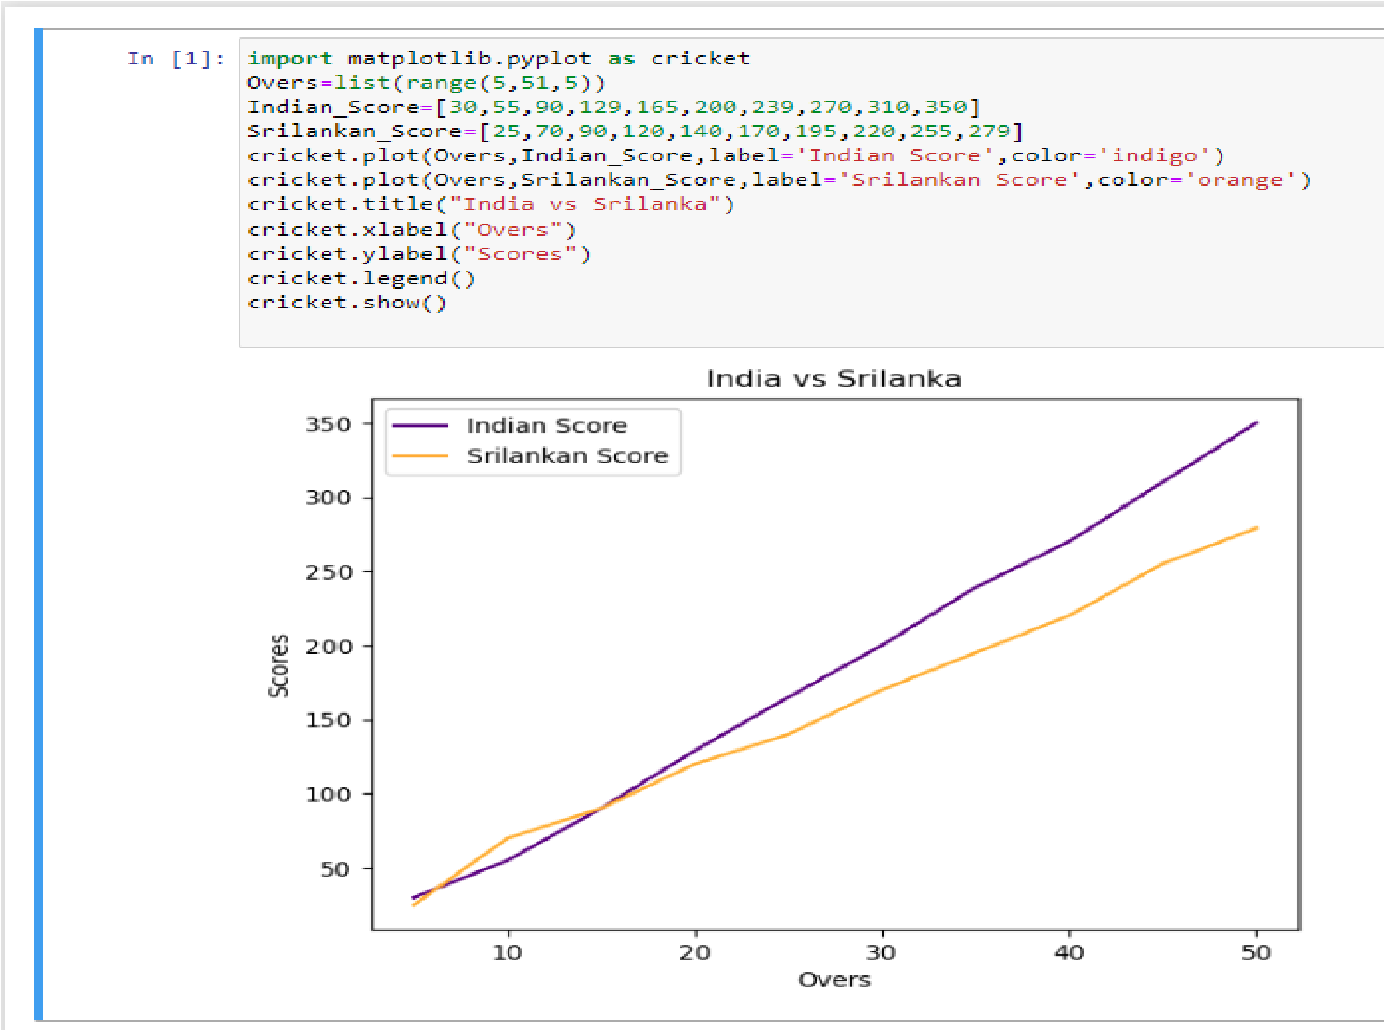

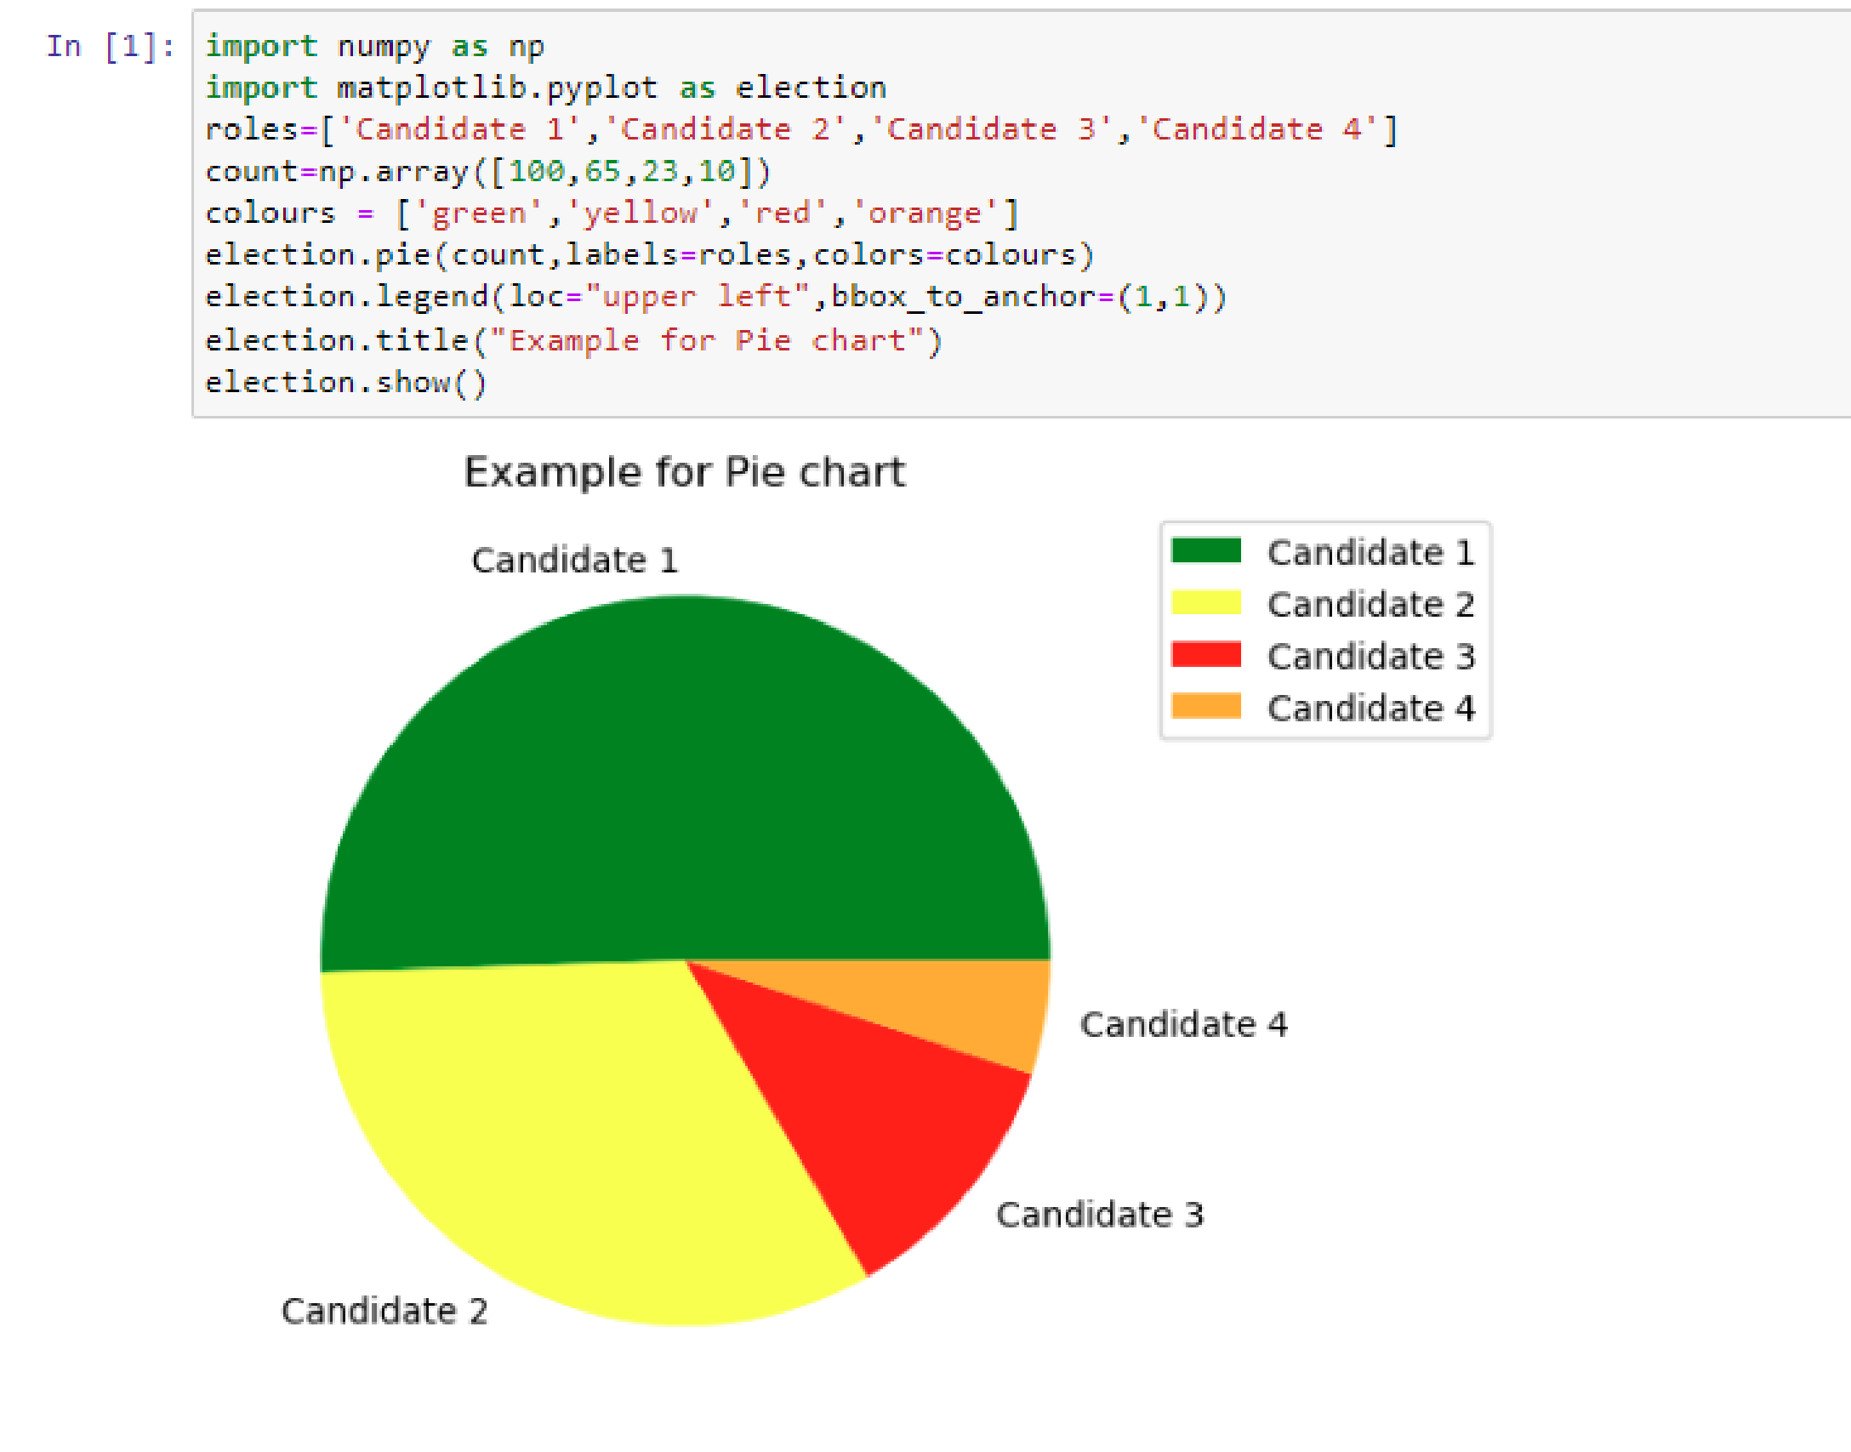*Experiment to show data visualization using pie chart*

Experiments on Structured,

Unstructured and Semi Structured

import pandas as pd structured_data=pd.DataFrame({

'ID': [1,2,3], 'Name': ['Alice', 'Bob', 'Charlie'], 'Age': [25,30,35]

})

print("Structured data: \n", structured_data)

unstructured_data="This is an example of unstructured data. It can be a piece of text, an image, or a video file." print("Unstructured data: \n", unstructured_data) semi_structured={'ID': 1, 'Name': 'Alice', 'Attributes': {'Height’:165, 'Weight':68}} print("Semi Structed data: \n", semi_structured)

**output:**

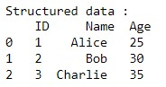



Using Pandas for data manipulation and Matplotlib for visualization

Import pandas as pd

Import matplotlib.pyplot as plt

data ={'Year’: list(range (2010,2021)), ‘job posting’: [150, 300, 450, 600, 800, 1200, 1600, 2100, 2700,

3400,4200]} df = pd.DataFrame(data) plt.plot (df['Year'], df['job posting'], marker='o') plt.title('trend of data science job postings') plt.xlabel('year') plt.ylabel('number of job postings') plt.show()

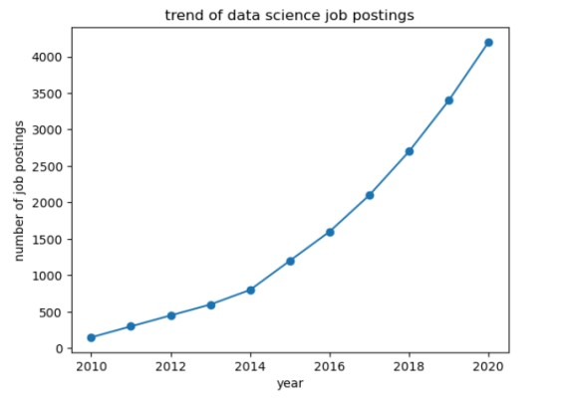

# 4: DATA PREPROCESSING

NAME: Gopikrishnan L

ROLL NO: 230701096

import pandas as pd import numpy as np

from sklearn.preprocessing import LabelEncoder, StandardScaler

df = pd.read_csv('Hotel_Dataset.csv')

print("Original Dataset:") print(df.head())

df.replace({'Bill': { -1: np.nan, -99999: np.nan, 0: np.nan},

'NoOfPax': {-1: np.nan, 0: np.nan},

'EstimatedSalary': {-99999: np.nan, 0: np.nan},

'Rating(1-5)': { -1: np.nan}}, inplace=True)

df = df.drop_duplicates()

df['Bill'] = df['Bill'].fillna(df['Bill'].mean())

df['NoOfPax'] = df['NoOfPax'].fillna(df['NoOfPax'].mode()[0]) # Mode for categorical-like column df['EstimatedSalary'] = df['EstimatedSalary'].fillna(df['EstimatedSalary'].mean()) df['Rating(1-5)'] = df['Rating(1-5)'].fillna(df['Rating(1-5)'].mode()[0])

label_encoder = LabelEncoder()

df['Hotel'] = label_encoder.fit_transform(df['Hotel'])

df['FoodPreference'] = label_encoder.fit_transform(df['FoodPreference'])

df = pd.get_dummies(df, columns=['Age_Group'], drop_first=True)

scaler = StandardScaler()

df[['Bill', 'EstimatedSalary']] = scaler.fit_transform(df[['Bill', 'EstimatedSalary']])

print("\nPreprocessed Dataset:")

print(df.head())

df.to_csv('Preprocessed_Hotel_Dataset.csv', index=False)

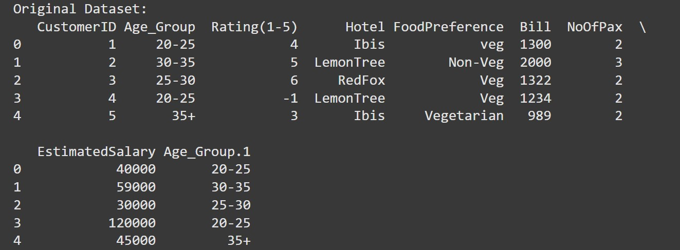

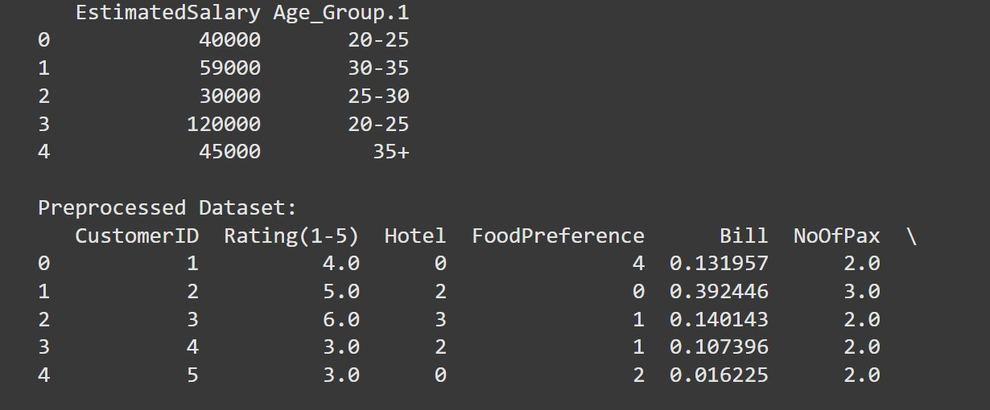

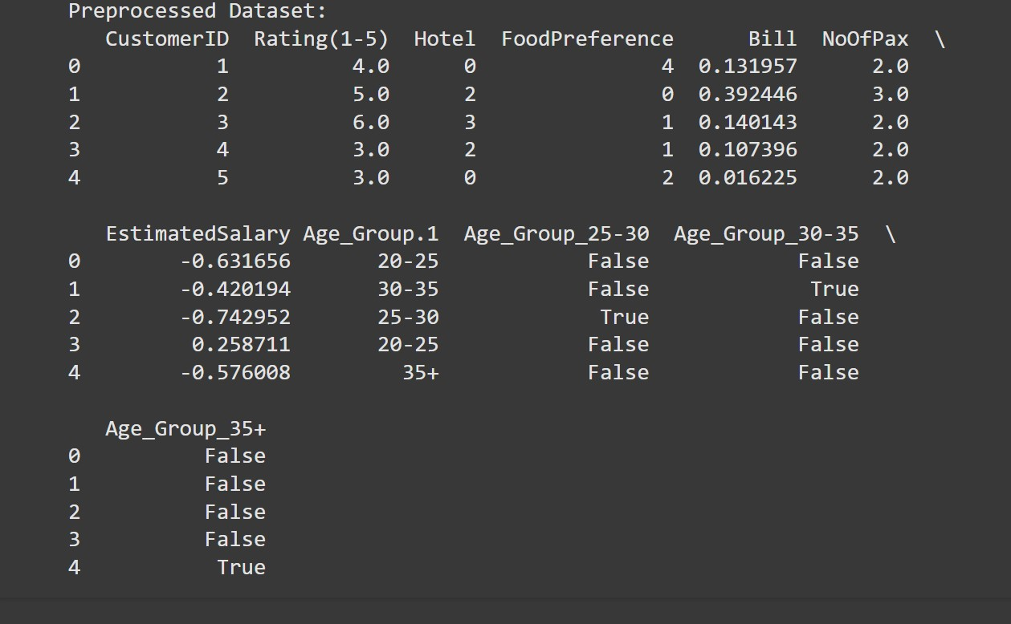

5: EDA quantitative and qualitative plot

NAME: GOPIKRISHNAN L

ROLL NO :230701096

import pandas as pd import matplotlib.pyplot as plt import seaborn as sns

data = {

'total_bill': [16.99, 10.34, 21.01, 23.68, 24.59],

'tip': [1.01, 1.66, 3.50, 3.31, 3.61],

'sex': ['Female', 'Male', 'Male', 'Male', 'Female'],

'smoker': ['No', 'No', 'No', 'No', 'No'],

'day': ['Sun', 'Sun', 'Sun', 'Sun', 'Sun'],

'time': ['Dinner', 'Dinner', 'Dinner', 'Dinner', 'Dinner'],

'size': [2, 3, 3, 2, 4]

}

df = pd.DataFrame(data)

# Set up Seaborn style for plots

sns.set(style="whitegrid")

# --------------------------

# Quantitative Plots

# --------------------------

plt.figure(figsize=(8, 6))

sns.histplot(df['total_bill'], kde=True, color='blue', bins=10)

plt.title('Distribution of Total Bill') plt.xlabel('Total Bill') plt.ylabel('Frequency') plt.show()

plt.figure(figsize=(8, 6))

sns.histplot(df['tip'], kde=True, color='green', bins=10) plt.title('Distribution of Tip')

plt.xlabel('Tip') plt.ylabel('Frequency') plt.show()

plt.figure(figsize=(8, 6)) sns.boxplot(x=df['total_bill'], color='orange')

plt.title('Boxplot of Total Bill') plt.xlabel('Total Bill')

plt.show()

plt.figure(figsize=(8, 6))

sns.scatterplot(x=df['total_bill'], y=df['tip'], color='purple')

plt.title('Total Bill vs Tip') plt.xlabel('Total Bill') plt.ylabel('Tip')

plt.show()

# --------------------------

# Qualitative Plots

# --------------------------

plt.figure(figsize=(8, 6)) sns.countplot(x='sex', data=df, palette='Set2') plt.title('Count of Customers by Sex')

plt.xlabel('Sex') plt.ylabel('Count') plt.show() plt.figure(figsize=(8, 6)) sns.countplot(x='smoker', data=df, palette='Set3') plt.title('Count of Smokers vs Non-Smokers')

plt.xlabel('Smoker') plt.ylabel('Count')

plt.show()

plt.figure(figsize=(8, 6)) sns.countplot(x='day', data=df, palette='muted') plt.title('Count of Customers by Day')

plt.xlabel('Day') plt.ylabel('Count') plt.show() plt.figure(figsize=(8, 6))

sns.countplot(x='time', data=df, palette='pastel') plt.title('Count of Customers by Time')

plt.xlabel('Time') plt.ylabel('Count')

plt.show()

sns.pairplot(df[['total_bill', 'tip', 'size']])

plt.suptitle('Pairplot: Total Bill, Tip, and Size', y=1.02) plt.show()

plt.figure(figsize=(8, 6))

sns.boxplot(x='sex', y='total_bill', data=df, palette='coolwarm')

plt.title('Boxplot of Total Bill by Sex') plt.xlabel('Sex') plt.ylabel('Total Bill')

plt.show()

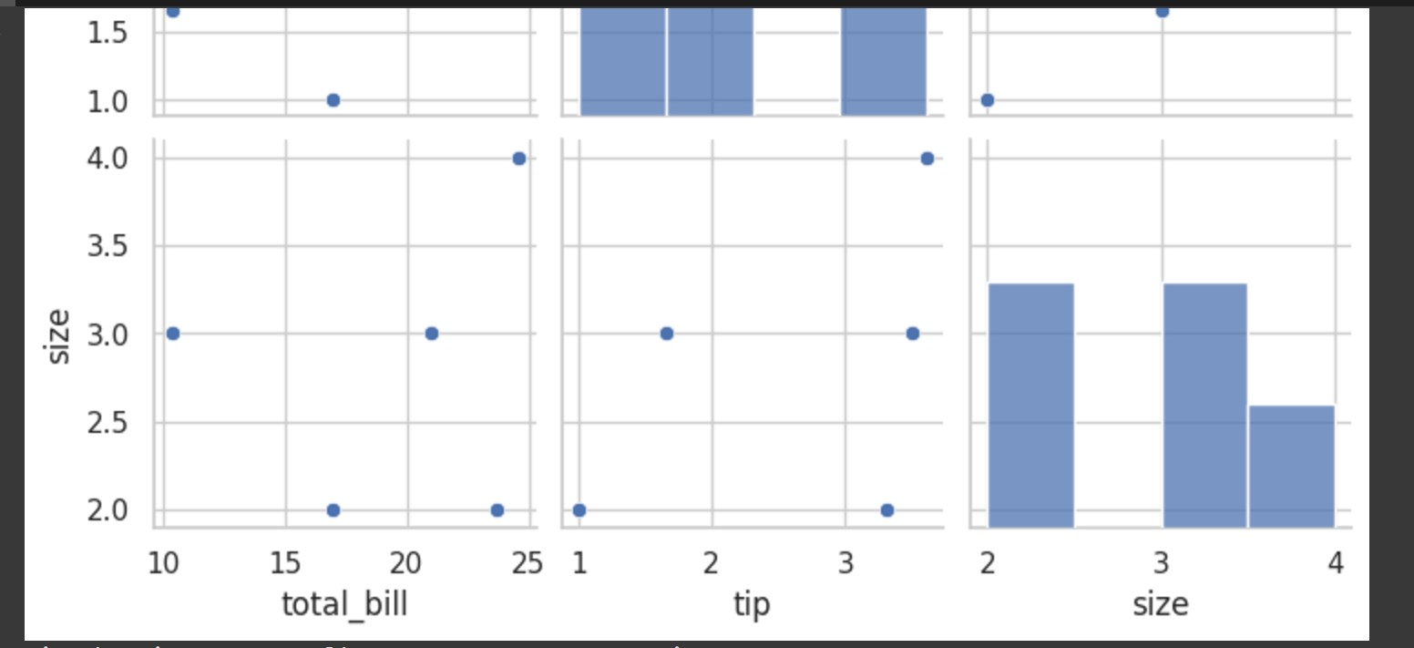

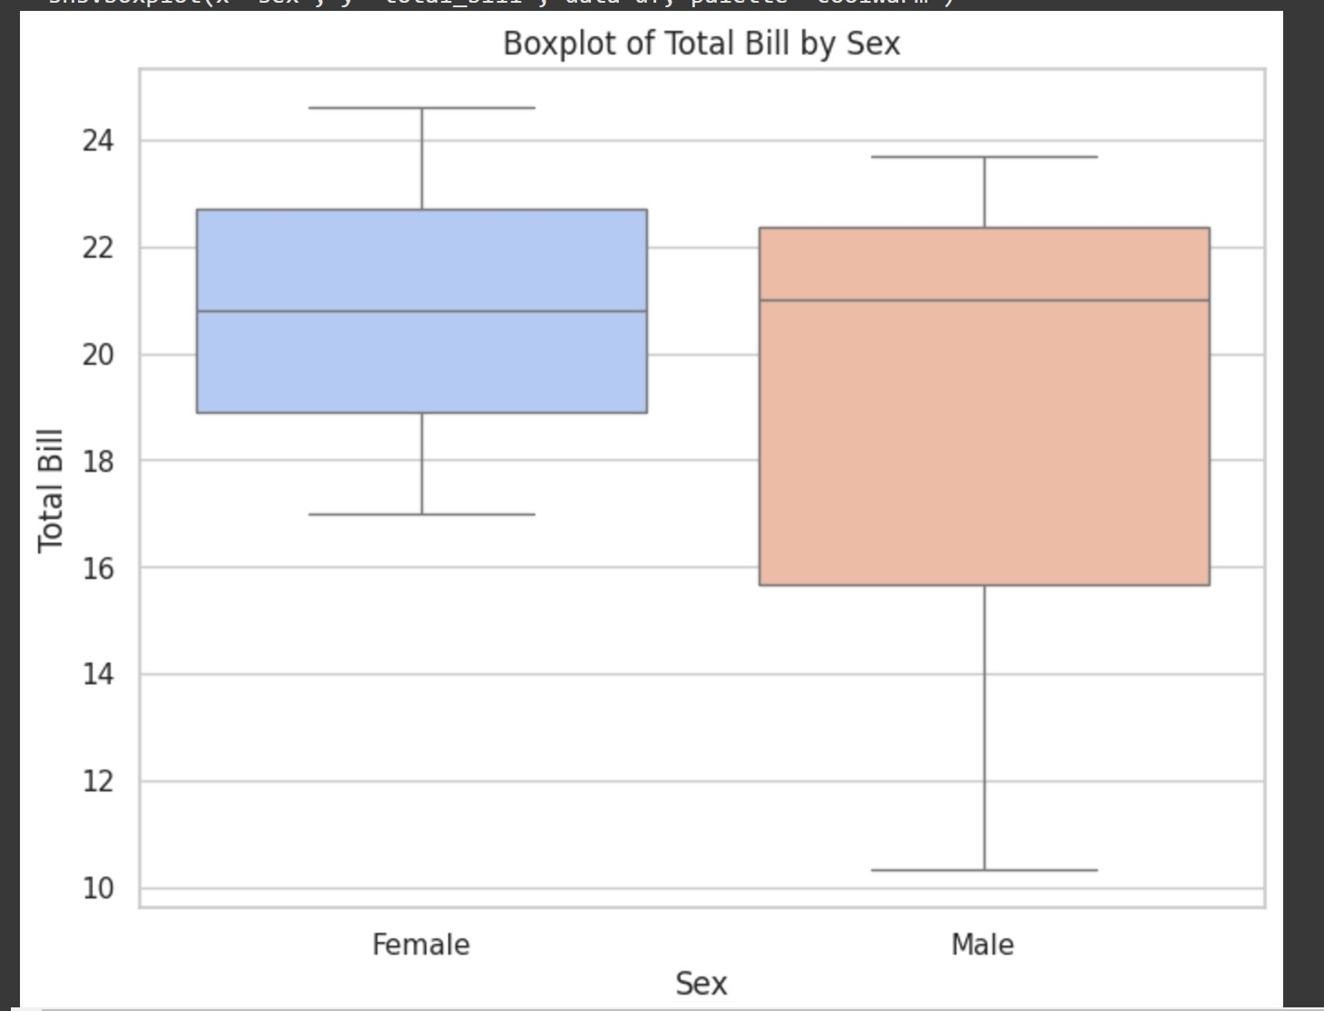

6: RANDOM SAMPLING AND SAMPLING

DISTRIBUTION

NAME: GOPIKRISHNAN L

ROLL NO: 230701096

import numpy as np import matplotlib.pyplot as plt

np.random.seed(42)

population = np.random.normal(loc=50, scale=10, size=10000) # Mean=50, SD=10, Population size=10,000

plt.figure(figsize=(8, 6))

plt.hist(population, bins=50, color='skyblue', edgecolor='black', alpha=0.7) plt.title('Population Distribution') plt.xlabel('Value') plt.ylabel('Frequency') plt.show()

sample_size = 100

random_sample = np.random.choice(population, size=sample_size, replace=False)

plt.figure(figsize=(8, 6))

plt.hist(random_sample, bins=30, color='salmon', edgecolor='black', alpha=0.7) plt.title(f'Random Sample Distribution (Sample Size = {sample_size})') plt.xlabel('Value') plt.ylabel('Frequency') plt.show()

num_samples = 1000 # Number of samples to draw sample_means = []

for _ in range(num_samples): sample = np.random.choice(population, size=sample_size, replace=False) sample_means.append(np.mean(sample))

plt.figure(figsize=(8, 6)) plt.hist(sample_means, bins=50, color='lightgreen', edgecolor='black', alpha=0.7) plt.title(f'Sampling Distribution of Sample Means (Sample Size = {sample_size}, Num

Samples = {num_samples})') plt.xlabel('Sample Mean') plt.ylabel('Frequency') plt.show()

print(f"Mean of population: {np.mean(population)}") print(f"Mean of sampling distribution: {np.mean(sample_means)}") print(f"Standard Deviation of population: {np.std(population)}")

print(f"Standard Deviation of sampling distribution: {np.std(sample_means)}")

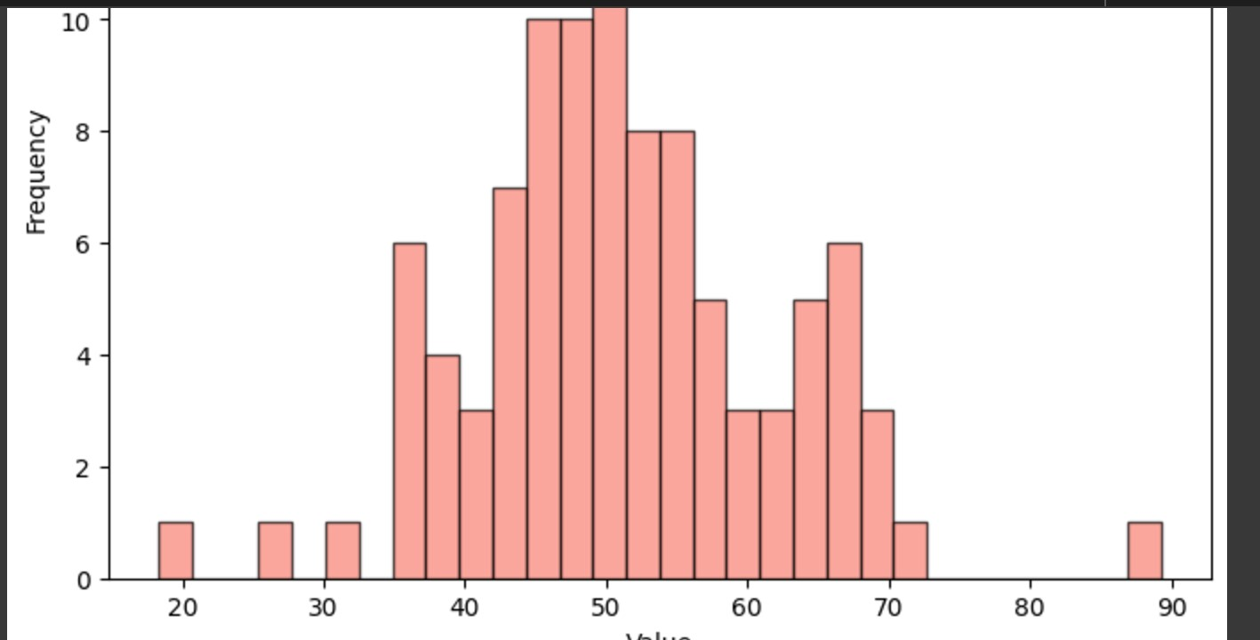

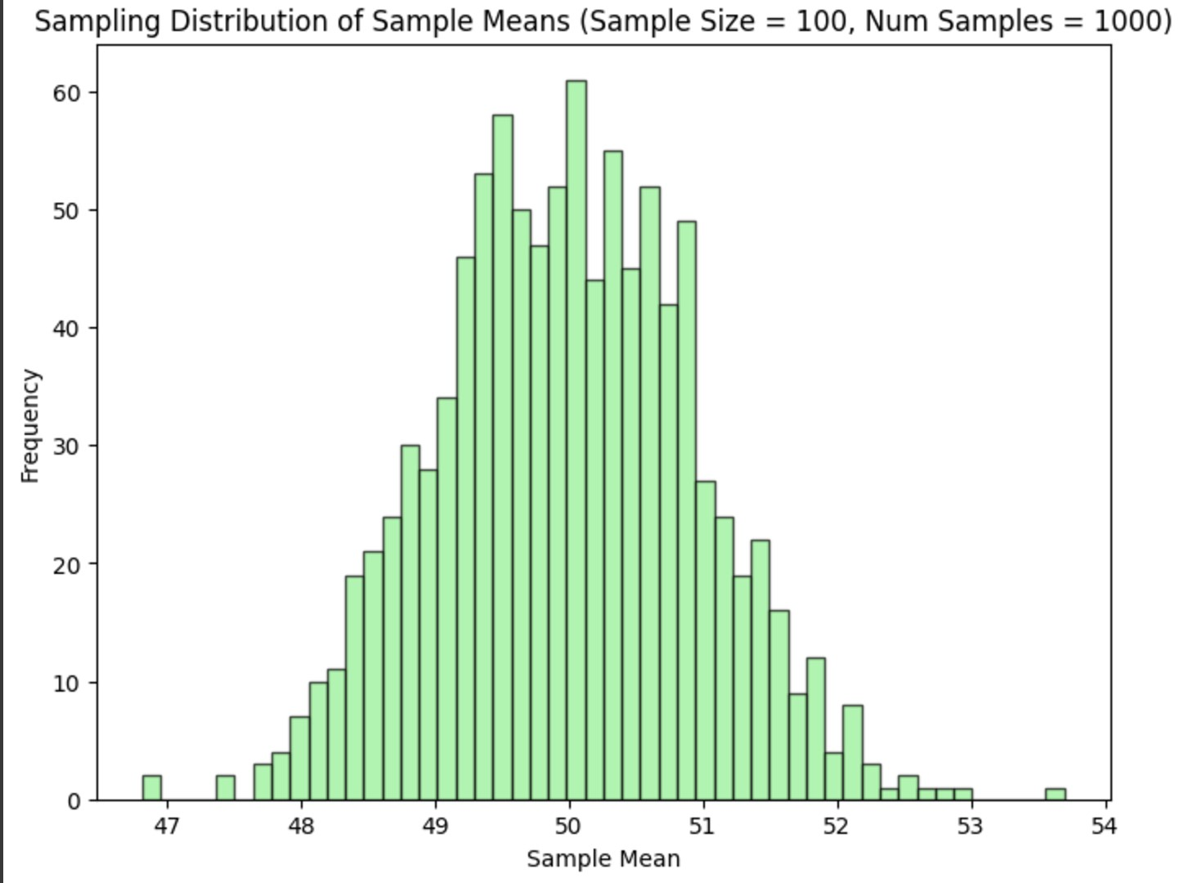

# **7. Z-TEST**

**NAME : Gopikrishnan**

**CLASS: CSE-B**

**ROLL NO : 230701096**

CODE:

import numpy as np

import scipy.stats as stats

# Define the sample data (hypothetical weights in grams) sample_data = np.array([152, 148, 151, 149, 147, 153, 150, 148, 152,

149,151, 150, 149, 152, 151, 148, 150, 152, 149, 150,148, 153, 151,

150, 149, 152, 148, 151, 150, 153]) # Population mean under the null hypothesis population_mean = 150

# Calculate sample statistics

sample_mean = np.mean(sample_data) sample_std = np.std(sample_data, ddof=1) # Using sample standard deviation

# Number of observations n = len(sample_data)

# Calculate the Z-statistic z_statistic = (sample_mean - population_mean) / (sample_std / np.sqrt(n))

# Calculate the p-value

p_value = 2 * (1 - stats.norm.cdf(np.abs(z_statistic))) # Two-tailed test

# Print results

print(f"Sample Mean: {sample_mean:.2f}")

print(f"Z-Statistic: {z_statistic:.4f}") print(f"P-Value: {p_value:.4f}")

# Decision based on the significance level alpha = 0.05 if p_value < alpha:

print("Reject the null hypothesis: The average weight is significantly different from 150 grams.")

else:

print("Fail to reject the null hypothesis: There is no significant difference in average weight from 150 grams.") **OUTPUT:**

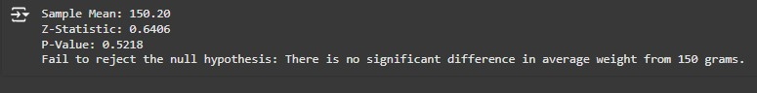

# **8. T-TEST**

**NAME : GOPIKRISHNAN L**

**CLASS: CSE-B ROLL NO : 230701096** CODE:

import numpy as np import scipy.stats as stats

# Set a random seed for reproducibility np.random.seed(42)

# Generate hypothetical sample data (IQ scores) sample_size = 25

sample_data = np.random.normal(loc=102, scale=15, size=sample_size) # Mean IQ of 102, SD of 15 # Population mean under the null hypothesis population_mean = 100

# Calculate sample statistics sample_mean = np.mean(sample_data) sample_std = np.std(sample_data, ddof=1) n = len(sample_data)

# Calculate the T-statistic and p-value t_statistic, p_value = stats.ttest_1samp(sample_data, population_mean)

# Print results

print(f"Sample Mean: {sample_mean:.2f}") print(f"T-Statistic: {t_statistic:.4f}") print(f"P-Value: {p_value:.4f}")

# Decision based on the significance level alpha = 0.05 if p_value < alpha:

print("Reject the null hypothesis: The average IQ score is significantly different from 100.") else:

print("Fail to reject the null hypothesis: There is no significant difference in average IQ score from 100.")

OUTPUT:

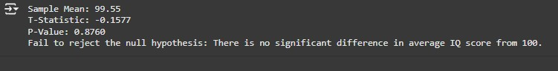

# **10.FEATURE SCALING**

**NAME : GOPIKRISHNAN L**

**ROLL NO : 230701096**

**AIM: To do feature scaling in the given dataset.**

import numpy as np import pandas as pd df=pd.read_csv('Data.csv')

df.head()

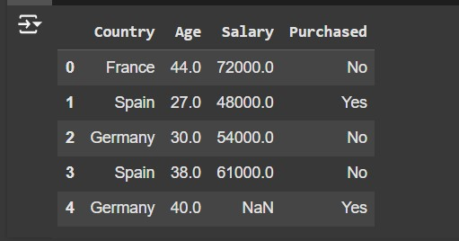

df.Country.fillna(df.Country.mode()[0],inplace=True) features=df.iloc[:,:-1].values label=df.iloc[:,-1].values

from sklearn.impute import SimpleImputer age=SimpleImputer(strategy="mean",missing_values=np.nan) Salary=SimpleImputer(strategy="mean",missing_values=np.nan)

age.fit(features[:,[1]])

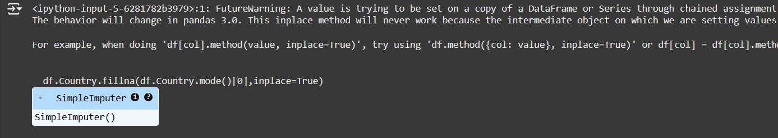

Salary.fit(features[:,[2]])

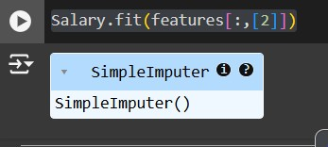

SimpleImputer()

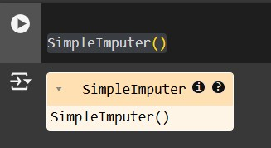

features[:,[1]]=age.transform(features[:,[1]]) features[:,[2]]=Salary.transform(features[:,[2]]) features

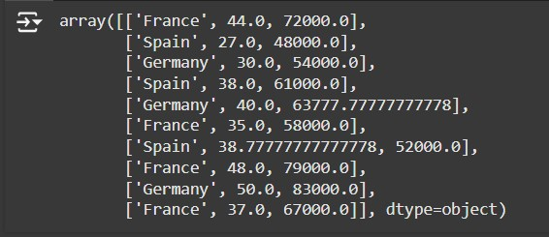

from sklearn.preprocessing import OneHotEncoder oh = OneHotEncoder(sparse_output=False)

Country=oh.fit_transform(features[:,[0]])

Country

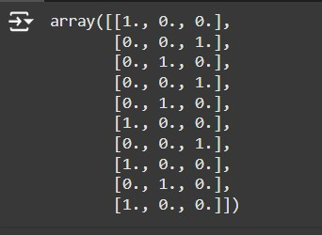

final_set=np.concatenate((Country,features[:,[1,2]]),axis=1)

final_set

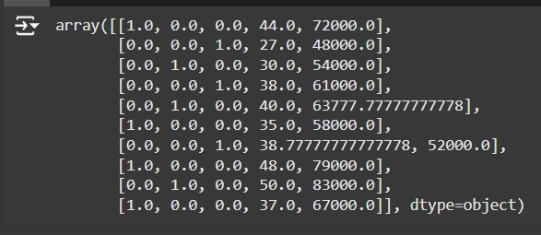

from sklearn.preprocessing import StandardScaler sc=StandardScaler() sc.fit(final_set)

feat_standard_scaler=sc.transform(final_set) feat_standard_scaler

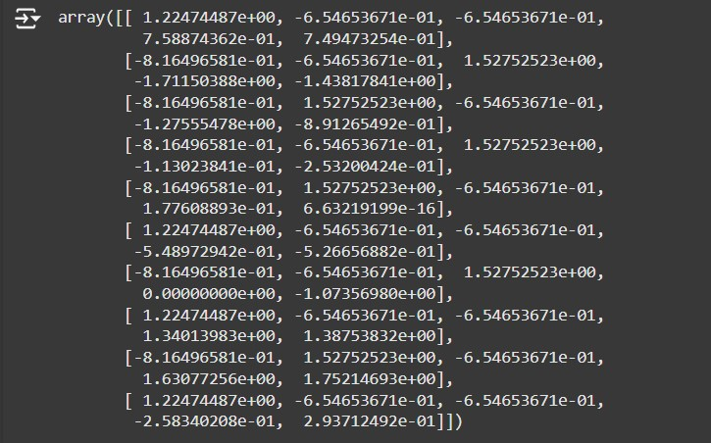

from sklearn.preprocessing import MinMaxScaler mms=MinMaxScaler(feature_range=(0,1)) mms.fit(final_set) feat_minmax_scaler=mms.transform(final_set) feat_minmax_scaler

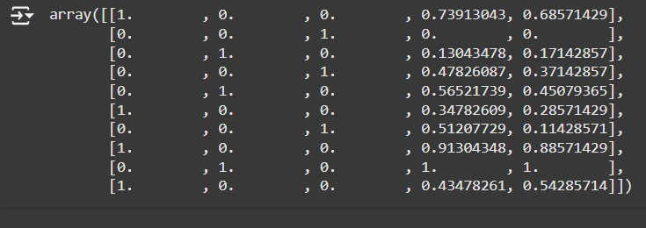

## 11.LINEAR REGRESSION

**NAME : DINISHA**

**CLASS: CSE-B**

**ROLL NO : 230701096**

import numpy as np import pandas as pd df=pd.read_csv('Salary_data.csv')

df.info()

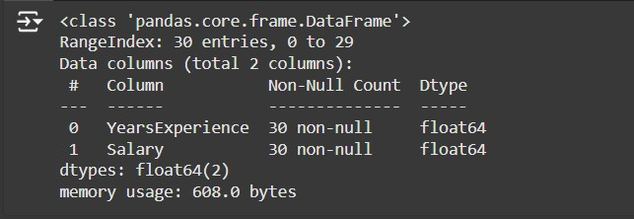

df.dropna(inplace=True)

df.info()

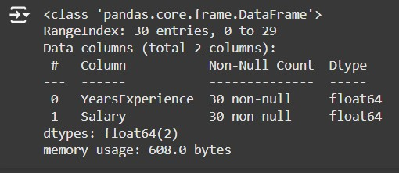

df.describe()

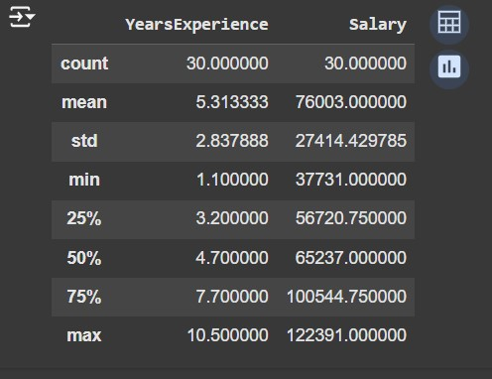

features=df.iloc[:,[0]].values label=df.iloc[:,[1]].values from sklearn.model_selection import train_test_split

# Assuming `features` and `label` are already defined in your code x_train, x_test, y_train, y_test = train_test_split(features, label, test_size=0.2, random_state=42)

from sklearn.linear_model import LinearRegression model=LinearRegression()

model.fit(x_train,y_train)

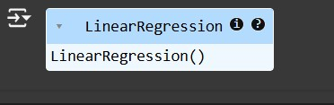

model.score(x_train,y_train)



model.score(x_test,y_test)



model.coef_



import pickle pickle.dump(model,open('SalaryPred.model','wb')) model=pickle.load(open('SalaryPred.model','rb')) yr_of_exp=float(input("Enter Years of Experience: ")) yr_of_exp_NP=np.array([[yr_of_exp]])

Salary=model.predict(yr_of_exp_NP)



print("Estimated Salary for {} years of experience is {}: " .format(yr_of_exp,Salary))



### 12. LOGISTIC REGRESSION

**NAME : GOPIKRISHNAN L**

**ROLL NO : 230701096**

import numpy as np import pandas as pd df=pd.read_csv('Social_Network_Ads.csv') df

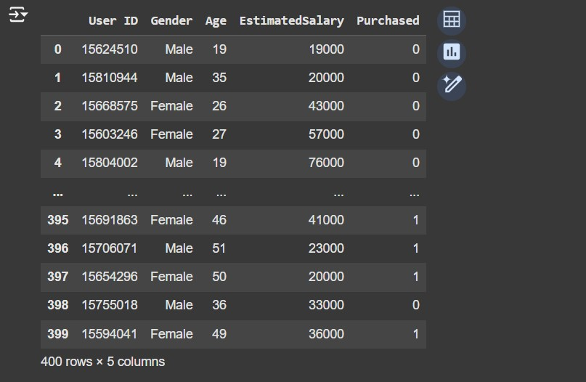

df.head()

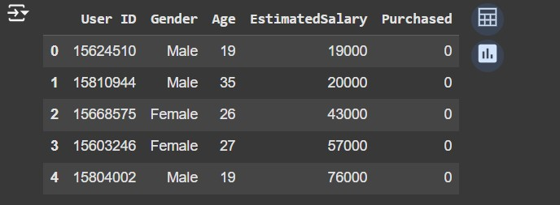

features=df.iloc[:,[2,3]].values label=df.iloc[:,4].values features

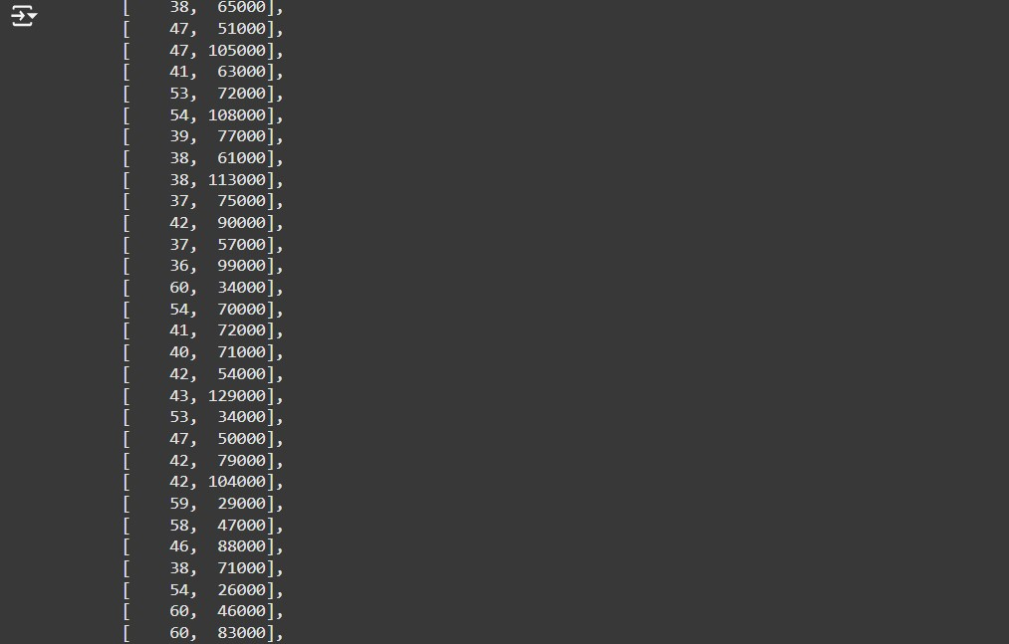

label

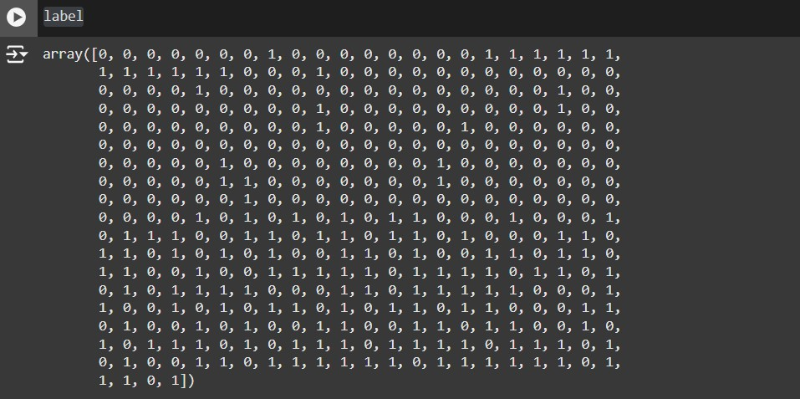

from sklearn.model_selection import train_test_split from sklearn.linear_model import LogisticRegression

for i in range(1, 401):

# Split the data into training and testing sets x_train, x_test, y_train, y_test = train_test_split(features, label, test_size=0.2, random_state=i)

# Initialize the Logistic Regression model model = LogisticRegression()

# Train the model model.fit(x_train, y_train)

# Calculate the train and test scores train_score = model.score(x_train, y_train) test_score = model.score(x_test, y_test)

# Print if test score is greater than train score if test_score > train_score:

print("Test {} Train {} Random State {}".format(test_score, train_score, i))

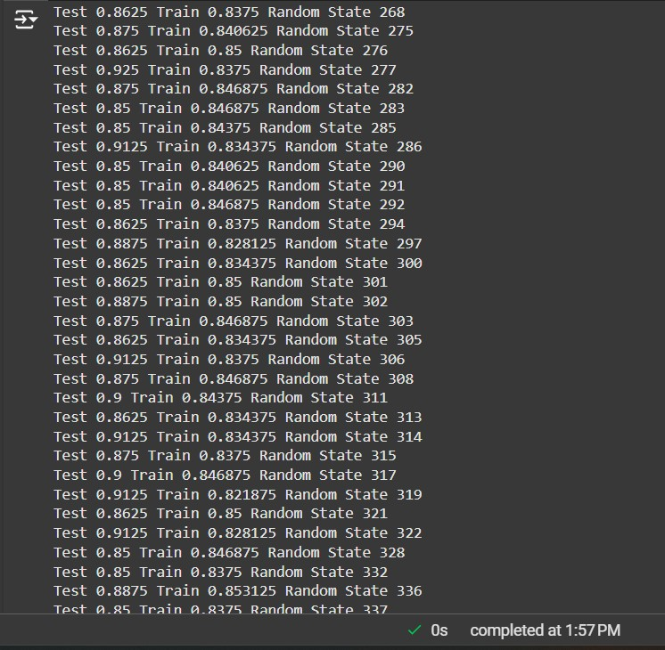

# Assuming features and label are defined earlier in your code x_train, x_test, y_train, y_test = train_test_split(features, label, test_size=0.2)

finalModel = LogisticRegression() finalModel.fit(x_train, y_train)

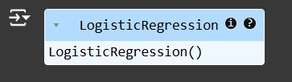

print(finalModel.score(x_train,y_train)) print(finalModel.score(x_test,y_test))

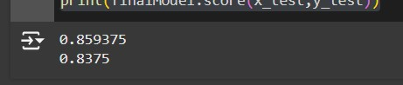

from sklearn.metrics import classification_report

print(classification_report(label,finalModel.predict(features)))

